

AN INTERNSHIP REPORT ON

Web Development
Submitted by

Barot Sarang Pravinbhai

220220131012

Student of

BACHELORS OF ENGINEERING
in
Computer Science & Engineering
Government Engineering College, Patan

Gujarat Technology University, Ahmedabad

July, 2025



Government Engineering College, Patan
At & Post: Katpur, Patan

CERTIFICATE

This is to certify that the project report submitted along with the project entitled Web Development has been carried out by Barot Sarang Pravinbhai under the guidance of Prof. Hiralben Rathod in partial fulfillment for the degree of Bachelor of Engineering in Computer Science & Engineering, 7th Semester of Gujarat Technological University, Ahmedabad, during the academic year 2025-26.

______________________ ______________________
Prof. Hiralben Rathod Dr. P. A. Barot
Internal Guide Head of the Department



DECLARATION

I do hereby solemnly declare that the work presented in this Internship Report has been carried out by me and has not been previously submitted to any other University, College, and Organization for any academic Qualification and Certificate.

I hereby warrant that the work I have presented does not breach any existing copyright acts.

Barot Sarang Pravinbhai
Student Name Student Sign

CONFIRMATION LETTER

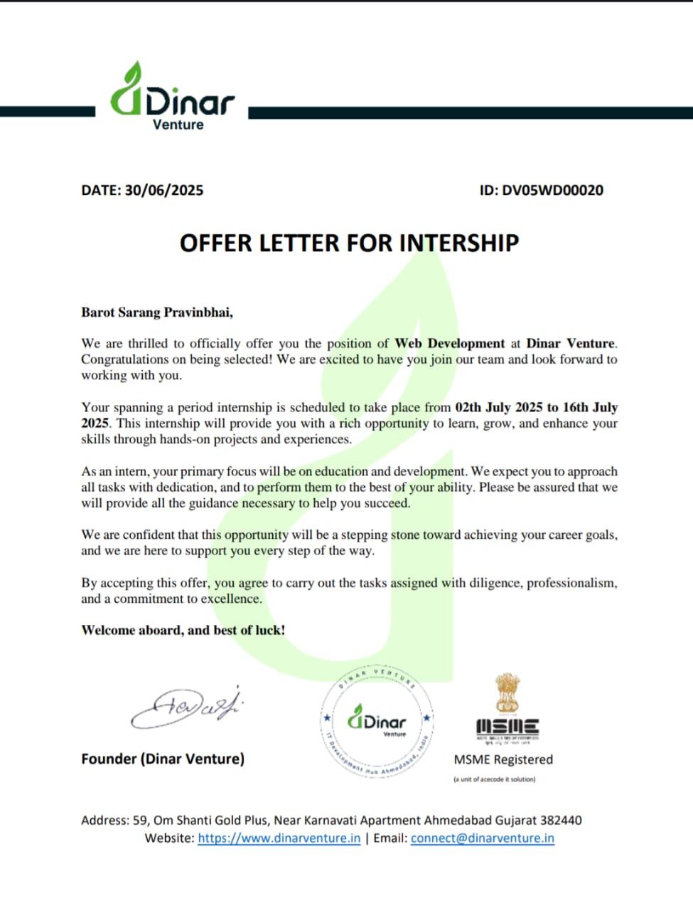

CERTIFICATE OF COMPLETION

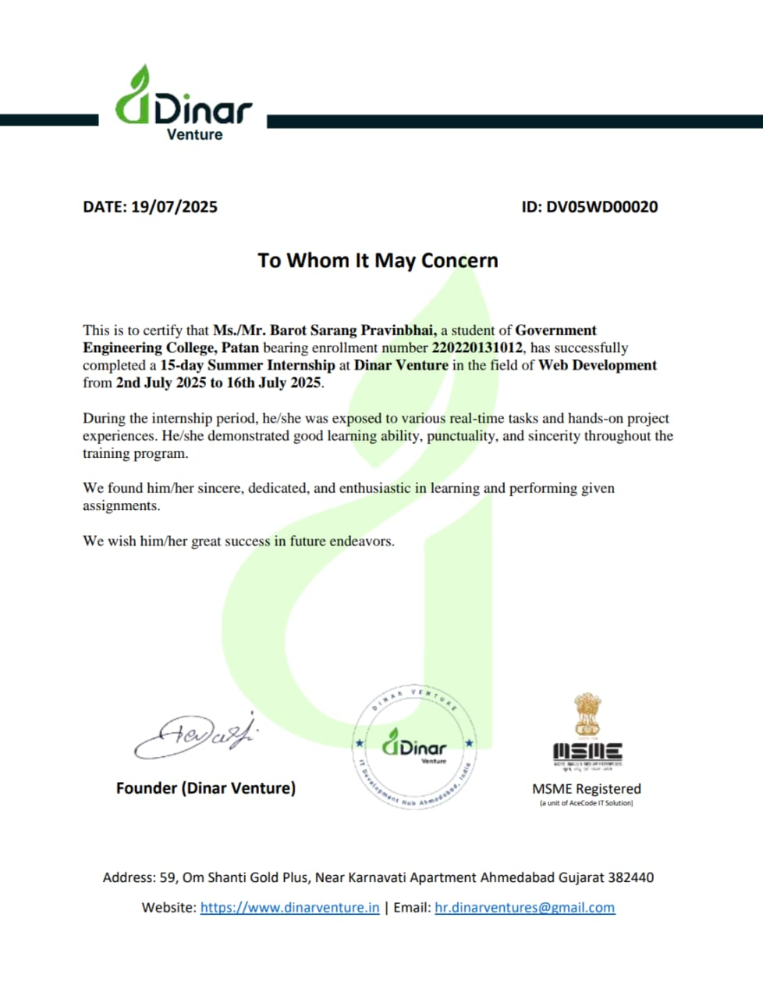

COMPANY PROFILE

Dinar Venture
Established in 2020, Dinar Venture is a forward-thinking IT services company based in Ahmedabad, Gujarat. The organization specializes in providing comprehensive digital solutions, including Web Development, Mobile App Development, Software Solutions, and Digital Marketing.
Our internship program focuses on Web Development, offering a hands-on learning experience for aspiring developers. Through this program, interns work on real-world projects using core technologies such as HTML, CSS, and JavaScript, gaining practical skills essential for today’s digital workforce.
With a commitment to fostering innovation and technical excellence, Dinar Venture has mentored numerous students, enabling them to transform their knowledge into industry-ready expertise. The program is led by experienced professionals who provide continuous guidance and project-based mentoring.
Our objective is to cultivate skilled developers ready to take on real-world challenges. Our mission is to deliver innovative digital solutions while empowering the next generation of web developers. Our vision is to build a digitally capable workforce that contributes meaningfully to the evolving tech landscape.

ACKNOWLEDGEMENT

I wish to express my sincere gratitude to my external guide, Mr. Dev Darji, for continuously guiding me at the company and answering all my doubts with patience. I would also like to thank my internal guide, Prof. Hiralben Rathod for helping me throughout the internship by offering valuable suggestions, timely feedback, and coordination in completing this internship.
I would also like to extend my heartfelt thanks to my parents, friends, and all the members of my family for their continuous support and encouragement throughout this journey. In addition to that, I would like to mention the team at Dinar Venture for granting me the opportunity to work with their resources and for providing a professional environment that helped me gain practical experience.
Thus, in conclusion, I once again thank the staff members and mentors at Dinar Venture for their valuable guidance and support in completing this internship.

Thank you.

ABSTRACT

During my 15-day internship at Dinar Venture, I gained comprehensive knowledge in Web Development, focusing on the core technologies of HTML, CSS, and JavaScript. The internship emphasized hands-on skills such as building responsive user interfaces, implementing interactivity with JavaScript, and designing visually appealing layouts. Throughout the program, I developed a mini portfolio website, which involved real-time deployment practices, modern UI styling, and project documentation. This practical exposure not only deepened my understanding of front-end technologies but also enhanced my problem-solving abilities and creativity in designing user-centric web solutions. The experience has significantly prepared me for future opportunities in the field of web development

TABLE OF CONTENTS

Sr. No. | CONTENT | PAGE NO
1. | Certificate | I
2. | Declaration | II
3. | Confirmation Letter | III
4. | Completion Certificate | VI
5. | Company Profile | VII
1. | Internship Structure | 10-18
1.1 | Orientation Session
1.2 | Master Classes
 | - Master Class 1
 | - Master Class 2
 | - Master Class 3
 | - Master Class 4
2. | Learning Plan | 19-27
 | - Web Development Courses
3. | Project Overview | 28-29
3.1 | - Objectives and goals of the project
3.2 | - Tools and technologies
4. | Key Findings and Insights | 30-31
 | - Key Insights
 | - Actionable Insights
5. | Skills Developed | 32-33
 | - Technical Skills
 | - Soft Skills
6. | References | 34
 | - Summary of Internship Experience
 | - Preparation for Future Career
7. | Conclusion | 35

Internship Structure

  - Orientation Session
The internship started with an orientation session led by Dinar Venture. The session introduced students to the 15-day Web Development internship roadmap. We learned about technologies like HTML, CSS, JavaScript, and the importance of responsive design.

Learning Plan:
- The learning plan was divided into stages: basic web page structure using HTML, styling using CSS, interactive behavior using JavaScript, and deployment using Netlify.

Master Classes and Doubt Clearing Sessions
- Regular sessions were conducted to teach key concepts and clarify technical doubts. Mentors also guided us through projects like a Calculator App and a Portfolio Website

Final Deliverables
- Calculator Web App
- Personal Portfolio Website
- Final report with live project links
- Project hosted via Netlify
- Submission of completion documentation

- Certainly! Here’s a more detailed section for your report, elaborating on the master classes and doubt-clearing sessions:

Master Classes

i) Master Class 1: Introduction to HTML
The first master class of the internship introduced participants to HTML (HyperText Markup Language) — the foundational language of the web. This session focused on building a solid understanding of how HTML is used to structure and organize web content.
- Key Learnings:
- Basic Structure of an HTML Document:
  - Doctype declaration, <html>, <head>, and <body> tags.
  - Metadata usage like <title>, <meta>, and linking stylesheets.
- Common HTML Elements:
  - Headings (<h1> to <h6>), paragraphs (<p>), and line breaks (<br>).
  - Emphasis and formatting tags like <strong>, <em>, <u>, and <span>.
- Working with Lists:
  - Ordered (<ol>) and unordered (<ul>) lists with list items (<li>).
- Hyperlinks and Anchors:
  - Use of <a href=""> for navigation within or outside the site.
  - Anchor linking for same-page navigation using id and #.
- Images and Media:
  - Inserting images using <img src="" alt="">.
  - Understanding alt attribute for accessibility.
- Tables and Layout:
  - Structuring tabular data with <table>, <tr>, <td>, and <th>.
- Forms and Input Fields:
  - Introduction to basic form elements like <input>, <label>, <textarea>, <select>, and <button>.
- Semantic HTML Tags:
  - Usage of modern semantic tags like <header>, <nav>, <section>, <article>, <footer> to improve accessibility and SEO.
- Hands-On Activity:
- Participants created a simple HTML portfolio skeleton with sections for Home, About, Projects, and Contact. This helped them understand how to logically structure content on a personal webpage.
ii) Master Class 2: Styling with CSS
The second master class of the internship focused on CSS (Cascading Style Sheets), where I gained comprehensive knowledge of how to design visually appealing and responsive websites. This session built upon the HTML fundamentals and emphasized separating content from presentation — a key web development practice.
- Key Learnings:

- CSS Fundamentals:
  - Structure of a CSS rule (selector, property, value).
  - Types of CSS: Inline, Internal, and External stylesheets.
  - Importance of maintainability and reusability through external CSS.
- Selectors and Specificity:
  - Universal, element, class, ID, group, descendant, and pseudo-selectors.
  - How specificity and the cascade affect which styles are applied.
- Color and Aesthetic Control:
  - Using color, background-color, and gradients.
  - Working with rgba(), hex values, and transparency effects.
  - Applied background images and practiced layering using background-blend-mode.
- Typography and Text Styling:
  - Font properties (font-family, font-size, font-weight, etc.).
  - Text decoration, alignment, spacing, and transformation.
  - Usage of Google Fonts for modern web typography.
- Box Model and Spacing:
  - Detailed understanding of margin, padding, border, and content.
  - Visual debugging using developer tools to inspect element boundaries.
  - Practical implementation through project layout adjustments.
- Layout Techniques:
  - Flexbox: Alignment, distribution of space, and orientation of items in a container.
  - Grid Layout (intro): Structured content in rows and columns.
  - Built project sections like hero, about, and contact using Flexbox.

- Styling UI Components:
  - Buttons with hover effects, transitions, and box shadows.
  - Card layouts for project showcases with borders, gradients, and rounded corners.
  - Customizing form elements (input, textarea, button) for contact sections.
- Responsive Web Design:
- Introduction to media queries to make web pages responsive across devices.
- Used relative units (%, em, rem, vw, vh) for scalable styling.
- Previewed projects on different screen sizes using Chrome DevTools.

- Practical Implementation:

During this session, I applied CSS to enhance my personal portfolio website. Key components styled include:
- The navigation bar has with horizontal menu, active link highlights, and fixed positioning.
- The hero section with a gradient background, a profile photo border, and centered intro text.
- The About Me and skills section, structured using Flexbox and styled with a modern dark theme.
- The project card layout, including hover animations, image scaling, and gradient buttons.
- Contact form styling using input focus states, background filters, and border-radius.

iii) Master Class 3: Introduction to JavaScript
The third master class focused on JavaScript, the language that brings web pages to life by enabling dynamic content, user interactivity, and logic-based functionality. As part of the internship, this session was essential in helping me bridge the gap between static websites and fully interactive applications.

- Key Concepts Covered:

- Basics of JavaScript Syntax and Structure:
- How to link JS to HTML using <script> and external .js files.
- Introduction to comments, statements, blocks, and semicolons.
- Understanding the execution flow of JavaScript in the browser.

- Variables and Data Types:
- Declaring variables using var, let, and const and understanding their scope.
- Working with primitive data types:
- String, Number, Boolean, Undefined, Null, Symbol
- Type conversion: implicit and explicit casting (e.g., "5" * 2 → 10)

- Operators and Expressions:
- Arithmetic (+, -, *, /, %, ++, --)
- Comparison (==, ===, !=, !==, <, >, etc.)
- Logical (&&, ||, !)
- Assignment and shorthand operators (+=, -=)

- Control Flow and Decision Making:
- if, else if, else statements
- switch-case for multi-condition decisions
- Error handling using try-catch (briefly introduced)

- Loops and Iteration:
- for, while, do-while loops
- Loop control: break, continue
- Looping over arrays using for and forEach()

- Functions:
- Declaring functions with the function keyword
- Function parameters and return values
- Arrow functions ()=>{} and their use cases
- Function scope and closures

- DOM Manipulation (Document Object Model):

JavaScript's ability to access and modify HTML and CSS through the DOM was a major part of this session:
- Selecting elements:
- document.getElementById("id")
- document.querySelector(".class")
- Changing content:
- .innerText, .innerHTML, .value
- Changing style dynamically:
- element.style.color = "red"
- Creating and deleting elements using createElement() and remove()
- Working with classes using .classList.add() / .remove() / .toggle()

- Hands-On Implementation During Internship:

- Calculator App (Project Demo):
- Built a fully working calculator that handles basic arithmetic:
  - Numbers and operators rendered using buttons
  - eval() used for result computation
  - C button clears the input
- Demonstrated real-time value updates via onclick and innerText

- Form Validation:
- Created input validation for contact form:
- Checked for empty fields
- Displayed alert messages
- Prevented submission if validation failed

- Portfolio Enhancement:
- Added interactive hover and click effects on project cards
- Enhanced navigation experience
- Built event-driven logic to improve user flow

- Tools and Platforms Used:
- VS Code: Writing and testing JavaScript code
- Browser Console (DevTools): Debugging and inspecting behavior
- GitHub: Pushing project updates and reviewing live behavior
- Netlify: Testing deployment behavior of JS scripts

- Key Outcomes:
- Strengthened logic-building skills through real-world examples
- Developed a solid base for moving into advanced JavaScript topics such as:
- Async JS (callbacks, promises)
- Local storage/session storage
- JavaScript animations and sliders
- Prepared to handle larger-scale projects using JS, like interactive dashboards or form-based applications

iv) Master Class 4: Web Projects & Responsive Design
This session focused on integrating previously learned skills, HTML, CSS, and JavaScript, into complete, real-world web development projects. The primary emphasis was on building mini portfolio websites with an understanding of responsive design principles to ensure compatibility across devices and screen sizes.

- Key Concepts Covered:

- Project Planning: Understanding how to break down a web project into components such as navigation, hero sections, project cards, and contact forms.
- File Organization: Learning best practices for structuring a project folder using separate files for HTML, CSS, JavaScript, and images.
- Responsive Design Techniques:

- Using media queries to optimize layout for various screen sizes.
- Applying flexbox and grid layouts for adaptive UI behavior.
- Testing responsiveness using Chrome Developer Tools and Live Server.

- Practical Implementation:

- Created a fully responsive Mini Portfolio Project consisting of:

- A Hero Section with a background image and animated intro text.
- Project Cards showcasing live demo links and GitHub source code.
- A Contact Form with JavaScript validation for required fields.
- Integrated social media icons styled with hover effects and centered placement.

- Applied UI styling such as:

- Gradient backgrounds and dark mode themes.
- Custom buttons, shadows, hover effects, and modern font choices.
- Adaptive images (like hero-bg.jpg and calculator-preview.png) handled via CSS.

- Tools & Workflow:

- Used VS Code with Live Server for real-time previewing.
- Deployed the project using Netlify, understanding domain setup and live hosting.
- Practiced using GitHub for version control and code hosting.

- Outcome:
By the end of this master class, I had successfully built and published a portfolio website that demonstrated my capabilities in front-end development. The emphasis on responsiveness helped me understand real-world expectations in professional web design, setting a strong foundation for future projects.
v) Master Class 5: Hosting & GitHub Deployment
This session provided a hands-on understanding of how to take locally developed web projects and publish them online using GitHub and Netlify. The goal was to help interns showcase their work professionally with live URLs that can be shared in resumes, LinkedIn profiles, and portfolios.

- Key Concepts Covered:

- Version Control Basics:

- Introduction to Git and GitHub.
- Creating and managing repositories.
- Understanding commit, push, pull, and clone operations.
- Project Deployment Using GitHub Pages:

- Steps to upload a website folder to a GitHub repository.
- Configuring the GitHub repository for hosting via GitHub Pages.
- Obtaining a live project link and testing it in browsers.
- Introduction to Netlify Hosting:

- Setting up a Netlify account.
- Drag-and-drop deployment method.
- Continuous deployment via GitHub linking.
- Understanding site settings and auto-updates on commit.

- Step-by-Step Activities Performed:

- Created a GitHub repository named my-calculator and uploaded project files using drag-and-drop and Git commands.
- Published the project via GitHub Pages and verified the live link.
- Registered on Netlify, deployed the same project using drag-and-drop, and received a unique live URL.
- Learned how to:

- Rename the default Netlify URL.
- Connect Netlify to GitHub for continuous deployment.
- View and debug deployment status on the Netlify dashboard.

- Practical Outcome:

- Successfully deployed the Mini Portfolio Website and Calculator Project using both GitHub Pages and Netlify.
- Projectlink:
https://poetic-cucurucho-7fa76b.netlify.app
- Understood how to:

- Maintain public visibility of work.
- Host static sites quickly and for free.
- Troubleshoot deployment issues like broken links or missing files.
- Tools Used:
- GitHub
- Netlify
- VS Code for project preparation
- Google Chrome Developer Tools for testing responsiveness post-deployment

- Skills Gained:
- Git & GitHub basics
- Static site deployment
- Continuous deployment pipelines
- Domain management basics on Netlify
- Confidence in sharing work professionally via hosted URLs.

Learning Plan
- Overview:
During the 15-day internship program at Dinar Venture, we followed a structured and practical learning path focused on core web development technologies. The learning plan was designed to introduce students to front-end web development from scratch using real-world applications and projects.

- Courses and Key Learnings:

  - Introduction to Web Development:
- Gained a basic understanding of how the web works, including how browsers (clients) and servers communicate over the internet.
- Learnt the structure of a typical website using HTML, CSS, and JavaScript.
- Understood the difference between:
- Frontend (client-side: what the user sees and interacts with).
- Backend (server-side: where data processing and logic happen).
- HTML was introduced as the building block of web pages, helping create structure using tags like <h1>, <p>, <img>, <a>, and <div>.
- CSS was used for styling HTML elements, including colors, fonts, spacing, layouts, and responsive design techniques.
- JavaScript was introduced for adding interactivity, such as validating forms, handling button clicks, and updating content dynamically.
- Learnt how the DOM (Document Object Model) works and how JavaScript can manipulate it to change webpage content in real time.
- Practiced linking external CSS and JS files to maintain cleaner and more organized code.
- Explored browser Developer Tools (e.g., Chrome DevTools) to inspect elements, debug errors, and monitor performance.
- Understood how to create a proper project folder structure, organize files, and follow naming conventions for web development.
- Learned the overall workflow of how a simple webpage loads from the server to the browser.

  - HTML Essentials:

- Learned how to set up the basic structure of an HTML document using <!DOCTYPE html>, <html>, <head>, and <body> tags.

- Understood the role of semantic HTML elements such as <header>, <footer>, <section>, <article>, and <nav> for improving readability, accessibility, and SEO.

- Practiced using text-level elements like <h1> to <h6>, <p>, <span>, <strong>, and <em> to format and organize textual content.

- Gained experience in creating and styling hyperlinks using the <a> tag with attributes like href, target, and download.

- Implemented image and media embedding using <img>, <audio>, and <video> elements with appropriate attributes such as src, alt, controls, width, and height.

- Explored how to create ordered lists (<ol>), unordered lists (<ul>), and definition lists (<dl>) for presenting grouped data.

- Built and formatted HTML tables using <table>, <tr>, <td>, <th>, and advanced attributes like colspan, rowspan, and table borders.

- Designed HTML forms using <form>, <input>, <label>, <select>, <textarea>, <button>, and used different type attributes for varied input (e.g., text, email, password, radio, checkbox, file, etc.)

- Used action and method attributes in forms to understand how data is submitted to a server.

- Applied inline, internal, and external CSS linking for styling HTML content during exercises.

- Focused on writing clean and well-indented HTML code, adhering to best practices for readability and maintainability.
  - CSS for Styling:
- Understood the role of CSS in enhancing the visual presentation of web pages by separating content (HTML) from design.
- Learned to apply CSS properties to control visual elements such as:
- Colors (color, background-color)
- Typography (font-family, font-size, font-weight, line-height, text-align)
- Spacing (margin, padding, gap)
- Box model concepts (border, width, height, box-sizing)
- Practiced selecting elements using:
- Element selectors (h1, p, div)
- Class selectors (.class-name) for reusable styles
- ID selectors (#id-name) for unique styling
- Pseudo-classes (:hover, :active, :first-child) for interactivity
- Worked with inline, internal, and external CSS to style elements and maintain code structure.
- Explored CSS Display properties like block, inline, inline-block, and none to control element behavior.
- Built layouts using Flexbox:
- Used properties like display: flex, justify-content, align-items, and flex-direction to align items efficiently.
- Designed responsive grids using CSS Grid:
- Utilized grid-template-columns, gap, grid-area, and place-items for modern layout systems.
- Applied media queries for responsiveness and adaptive design on different screen sizes.
- Added transitions and hover effects using transition, transform, and :hover to improve user experience.
- Created simple CSS animations using @keyframes and animation properties to animate elements like text or buttons.
- Customized buttons, navigation bars, cards, and forms using consistent design themes and variables.
- Focused on using CSS variables (--variable-name) and the :root selector for theme consistency and easy updates.
- Followed best practices like writing DRY (Don’t Repeat Yourself) CSS and using structured class naming conventions (e.g., BEM – Block Element Modifier).

  - Responsive Web Design:

- Understood the importance of responsive design in modern web development to ensure websites adapt seamlessly to different devices (mobile, tablet, desktop).
- Learned the concept of mobile-first design, where styling starts for smaller screens and scales up using media queries.
- Used CSS media queries (@media) to apply different styles at specific breakpoints, such as:
- max-width: 768px for tablets
- max-width: 480px for mobile devices
- Practiced building fluid layouts using:
- Percentages, em, rem units instead of fixed px for flexible sizing
- Viewport units like vw, vh to maintain proportion across screen sizes
- Applied Flexbox and CSS Grid to structure responsive page layouts efficiently with minimal media query adjustments.
- Built and tested mobile-friendly navigation menus using hamburger icons, dropdowns, and collapsible sections.
- Ensured images and videos scaled properly using:
- max-width: 100%
- object-fit: cover or contain for media elements
- Created responsive cards and forms, ensuring text, input fields, and buttons were legible and usable on smaller screens.
- Used developer tools in Chrome to simulate different devices and test responsiveness visually.
- Focused on touch-friendly design with proper button spacing, font sizes, and tap targets for better UX on mobile.
- Implemented responsive typography using clamp() and media queries to adapt text sizes for various screens.
- Practiced creating a responsive project landing page, including elements like hero sections, about blocks, and project cards.
- Followed best practices for accessibility and performance by avoiding overflow issues and ensuring smooth resizing.
  - JavaScript Fundamentals:
- Gained hands-on understanding of JavaScript as a scripting language that adds dynamic behavior to static HTML/CSS pages.
- Learned how to embed JavaScript using <script> tags and external .js files.
- Practiced using basic syntax, including:
- Variables (let, const)
- Data types (strings, numbers, booleans)
- Operators, expressions, and conditional statements (if-else, switch)

- Implemented functions to modularize code and reuse logic efficiently.
- Worked with loops (for, while) to iterate over arrays and perform repetitive tasks.
- Used event listeners (e.g., click, mouseover, keyup) to trigger actions and interact with users in real-time.
- Practiced DOM manipulation:
- Accessed elements using getElementById, querySelector
- Changed styles, content, and attributes dynamically
- Built interactive UI elements such as:
- Calculator logic for arithmetic operations
- Show/hide toggle effects
- Input validations in forms
- Learned to use alert, console.log, and prompt for debugging and input/output interactions.
- Applied form validation logic to check for empty fields, validate emails, and restrict special characters using JavaScript before form submission.
- Managed arrays and objects to store and retrieve structured data, such as lists of projects or user messages.
- Introduced to basic error handling using try-catch blocks.
- Developed mini projects like:
- Simple Calculator App: arithmetic operations using input values and button events.
- Form Validation Project: ensuring users fill out necessary information before submitting the form.
- Strengthened the understanding of how JavaScript, HTML, and CSS work together to create interactive and engaging web pages.
  - Mini Projects:
- Calculator Web App:-
- Developed using HTML, CSS, and JavaScript.
- Implemented interactive buttons for digits, arithmetic operators (+, –, ×, ÷), and special keys like C (Clear) and = (Equals).
- Used JavaScript event listeners and DOM manipulation for real-time display updates.
- Applied modern CSS styles including button hover effects, dark-themed UI, and rounded elements.
- Ensured mobile responsiveness using media queries.
- Deployed the project via GitHub Pages.
Live Demo: Calculator Web App
- Personal Portfolio:-
- Designed a multi-section website including Home, About, Projects, and Contact sections.
- Showcased personal profile, project links, and a functional contact form.
- Used HTML for structure, CSS Flexbox and Grid for layout, and JavaScript for form validation.
- Included modern UI elements like animated transitions, hover effects, and gradient backgrounds.
- Built a fully responsive design for different screen sizes.
- Deployed the website using Netlify.
Live Portfolio: Portfolio Website
- Version Control & Hosting:

- Introduction to Git & GitHub:
- Learned the basics of version control and its importance in collaborative software development.
- Explored Git commands such as git init, git add, git commit, git push, and git pull for managing code changes.
- Created and managed repositories on GitHub to store, share, and collaborate on web development projects.
- Understood the concept of commits, branches, and merges for organizing development workflow.
- Practiced resolving merge conflicts and maintaining clean commit histories.
- GitHub Pages Deployment:
- Used GitHub Pages to host static web pages directly from GitHub repositories.
- Configured repositories for deployment by uploading project files and enabling GitHub Pages in repository settings.
- Understood the importance of index.html as the entry point for live websites.
- Tested and shared live project URLs with peers and mentors for feedback.
- Netlify Hosting:
- Gained hands-on experience deploying projects via Netlify.
- Connected GitHub repositories to Netlify for continuous deployment.
- Used drag-and-drop upload feature for quick deployment of static sites.
- Explored custom domain mapping, site settings, and live link management.
- Deployed the final portfolio project to Netlify for public access and presentation.
- Live Portfolio Project: https://poetic-cucurucho-7fa76b.netlify.app/
- Benefits of Hosting Platforms:
- Understood the role of CI/CD pipelines in professional environments.
- Explored deployment options for personal and client projects using free-tier hosting platforms.
- Learned how version control and cloud deployment support collaborative and scalable web development.

- Final Submission & Review:
- Mini Project Completion:
- Successfully completed two core web development mini projects:
- A functional Calculator Web App performing basic arithmetic operations using HTML, CSS, and JavaScript.
- A Personal Portfolio Website showcasing personal information, project details, and a contact form.
- Live Deployment of Projects:
- Deployed both projects on Netlify and GitHub Pages to make them accessible via live links.
- Ensured responsiveness and functionality across devices using media queries and JavaScript validation.
- Project Documentation:
- Prepared and submitted detailed documentation in PDF format, which included:
- Overview of the internship.
- Tools and technologies used.
- Project descriptions and live links.
- Certificate-style cover page, self-review slide, and thank-you note.
- Mentor Evaluation & Feedback:
- Shared the project with internship mentor Mr. Dev Darji for review.
- Received constructive feedback on design, structure, and functionality.
- Suggestions were implemented to improve responsiveness and user experience.
- Final Reporting:
- Uploaded the final report with all deliverables to the assigned Drive folder as per internship requirements.
- Maintained the naming format as: final_project_DV05WD00020.pdf.
- Reflected on learning outcomes and submitted self-assessment along with the project.
- Presentation Readiness:
- Ensured the project was ready for demonstration in any interview or academic setting.
- Used the experience as a foundation for portfolio building and resume enhancement.

Project Overview
3.1 Objectives and Goals of Project:
- Objective:
To design and develop a personal portfolio website using HTML, CSS, and JavaScript that showcases my skills, projects, education, and contact information in a professional and responsive manner.

- Goals:
- Understand Real-World Web Development Practices
Apply front-end technologies to develop a real working portfolio site from scratch.

- Build a Visually Appealing and Responsive UI
Use modern styling techniques (like Flexbox, Grid, and CSS variables) to ensure cross-device compatibility.

- Showcase Personal Skills and Projects
Include a “Projects” section with live demo links and GitHub code for recruiters or clients.

- Implement Contact Form with JS Validation
Add a working contact form with proper input validation using JavaScript.

- Deploy Live Website Using Netlify
Host the final portfolio online to make it publicly accessible.

- Gain Practical Experience in Code Structuring and Reusability
Organize HTML, CSS, and JS files effectively and maintain clean code practices.

3.2 Tools and Technology:
- HTML5
– For creating the basic structure and content of the web pages.

- CSS3
– For styling the layout, adding themes, and making the site visually engaging.

- JavaScript
– For adding interactivity, especially in the contact form validation.

- VS Code
– As the primary code editor used during development.

- Font Awesome
– To add modern social media icons and visual elements.

- Git & GitHub
– This is for version control and managing project source code.

- Netlify
– To deploy the project live on the internet.

- Responsive Design(Media Queries)
– To make the site mobile-friendly across different screen sizes.

Key Findings and Insights
4.1 Key Insights:
- Practical Experience in Frontend Web Development
Gained hands-on skills in structuring and styling web pages using HTML and CSS. Learned how to create responsive layouts and reusable components.
- Understanding of UI/UX Principles
Learned how design elements such as spacing, contrast, typography, and layout affect user experience. This was applied in building a user-friendly and visually appealing portfolio interface.
- Responsive Design Implementation
Successfully applied media queries and layout techniques (like Flexbox and Grid) to ensure the website works well on desktop, tablet, and mobile devices.
- Form Validation Using JavaScript
Added interactive form features such as input validation to improve the functionality and professionalism of the website.
- Use of GitHub for Version Control
Understood how to use Git and GitHub to manage project code, track progress, and publish live projects via GitHub Pages.
- Deployment Experience Using Netlify
Deployed the project online using Netlify, understanding how continuous deployment works and how to generate live links for public access.
- Improved File Structure and Code Organization
Practiced modular coding and separated structure (HTML), design (CSS), and logic (JS) to maintain readability and scalability of the project.
- Enhanced Creativity and Confidence
Built confidence in implementing custom designs and styling inspired by real-world references like the Career Compass project.

4.2 Actionable Insights:
- Apply Web Design Knowledge to Future Projects
Use this portfolio structure and styling approach for freelancing, personal branding, or academic projects.
- Continue Learning Advanced Web Technologies
Explore JavaScript frameworks like React, Vue, or Next.js to create more dynamic web applications.
- Optimize Code and Performance
Focus on performance improvements such as image optimization, file minification, and responsive best practices.
- Collect User Feedback
Share the portfolio with peers, mentors, or recruiters to get feedback and iterate on design and usability.
- Improve SEO and Accessibility
Apply semantic HTML and accessibility guidelines to improve discoverability and usability for all users.
- Integrate New Features in Future Versions
Add interactive elements like animations, dark mode toggle, or multi-page navigation to enhance user engagement.
- Use Portfolio for Job Applications
Attach the live portfolio link in resumes and LinkedIn profiles to showcase work to potential employers or internship providers.
- Experiment with Real-World Deployment
Explore custom domains, analytics tools, and web hosting services for a more professional project presentation.

Skills Development
5.1 Technical Skills:
- Frontend Web Development
- Gained practical knowledge of HTML5 for semantic page structure and content layout.
- Applied CSS3 for styling, layout (Flexbox, Grid), color schemes, and animations.
- Developed interactive features using JavaScript, such as dynamic DOM manipulation and form validation.
- Responsive Design
- Learned to create mobile-first responsive layouts using CSS media queries.
- Ensured cross-device compatibility using fluid grids and flexible images.
- Web Project Deployment
- Understood the project hosting workflow using platforms like GitHub Pages and Netlify.
- Published the mini portfolio website and managed links to GitHub repositories.
- Version Control with Git
- Learned basic usage of Git and GitHub for code versioning and collaborative development.
- Form Validation with JavaScript
- Implemented basic form validation using JavaScript to check for empty fields and email formatting.
- Tools Used
- Visual Studio Code (VS Code) as the primary code editor.
- Chrome Developer Tools for inspecting elements and debugging CSS/JS.
- Netlify for live project deployment.
- Git & GitHub for repository hosting and collaboration.

5.2 Soft Skills:
- Communication
- Learned to document code and projects effectively.
- Presented the portfolio project with clarity in the final submission.
- Problem-Solving
- Solved layout and styling issues using CSS properties.
- Debugged form handling and DOM errors in JavaScript.
- Time Management
- Completed all internship deliverables within the 15-day timeline.
- Balanced internship tasks with academic responsibilities effectively.

Conclusion

- Summary of Internship Experience:

The Web Development Internship at Dinar Venture provided a highly practical and skill-focused learning experience. Over the 15-day online internship, I gained hands-on exposure to core frontend technologies, including HTML5, CSS3, and JavaScript, which are essential for modern web development. The internship followed a structured learning path that included introductory tutorials, independent coding tasks, and final project implementation. Under the mentorship of Mr. Dev Darji, I successfully created a responsive personal portfolio website, featuring project showcases, contact forms, and live deployment using Netlify. Through this journey, I not only strengthened my technical abilities but also improved key professional skills such as project planning, version control with Git/GitHub, debugging, and user interface design. This experience has equipped me with the confidence and foundation needed to continue exploring web development and pursue further opportunities in the field.

- Preparation for Future Career:

The skills and experience gained during this internship have laid a strong foundation for my future career in web development and software engineering. Working with technologies such as HTML, CSS, and JavaScript has enhanced my ability to design responsive and visually appealing websites, while the completion of my portfolio project allowed me to apply these skills in a real-world context. This internship has not only improved my technical knowledge but also developed my confidence in independently managing front-end development tasks. It has given me a clearer understanding of industry expectations and project workflows, preparing me for future roles in web development, internships, or further studies in full-stack technologies. With this solid foundation, I am now better equipped to take on more complex web projects and continuously grow as a frontend developer.

References

- Dinar Ventures Internship Drive Folder:
https://drive.google.com/drive/u/0/folders/1XfOkgm0VijiSVpCT4lxrllcy3h7a-Xda
- Official Documentation:
  - MDN Web Docs – HTML
  - MDN Web Docs – CSS
  - MDN Web Docs – JavaScript
- Netlify Documentation:
- How to Deploy a Static Website on Netlify
- Additional Resource:
Practical guidance and troubleshooting techniques were also gathered from Stack Overflow, GitHub Discussions, and various frontend development blogs throughout the internship journey.

